Name: ______________________________________ Date: ________________________

Student Exploration: Sound Beats and Sine Waves

Vocabulary: amplitude, beat, constructive interference, crest, destructive interference, frequency, hertz, sound wave, trough

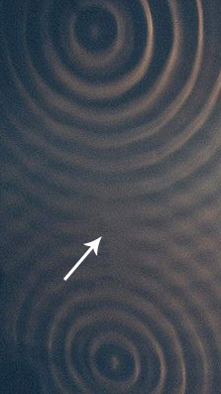
Prior Knowledge Questions (Do these BEFORE using the Gizmo.)

- The picture at left shows water ripples interacting. What do you notice about the area indicated by the arrow?

_______________________________________________

- Why do you think there are no distinct ripples in the area indicated by the arrow?

________________________________________________

________________________________________________

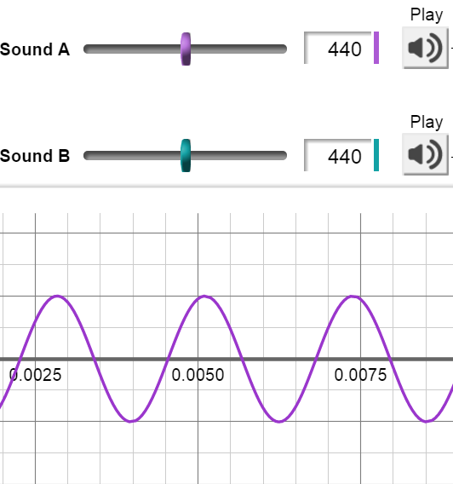
Gizmo Warm-up
Just like ripples on the surface of water, sound waves can interact with and influence each other. You can use the Sound Beats and Sine Waves Gizmo to explore two different types of sound wave interactions.

If you have headphones available, put them on now. Under Visual, turn on Sound A. Click the PLAY icon () next to the Sound A slider. Listen closely to the sound. Now, click PLAY next to the Sound B slider.

- How do the two sounds compare? _________
_____________________________________

- Click the PLAY icon under the word Auditory to play Sound A and Sound B together. How does this sound differ from Sound A and Sound B when they are played alone?

______________________________________________________________________

______________________________________________________________________
Activity A:  Constructive interference | Get the Gizmo ready:  - Make sure the Frequency for both Sound A and Sound B is set to 440 Hz.  - Check that the Visual for Sound A is on. | 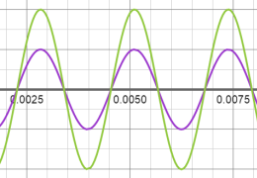
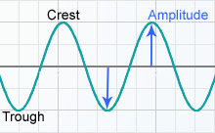
Introduction: The sine wave shown in the Gizmo represents a sound wave. Crests, or high points, correspond to places where air molecules are pushed together in a sound wave. Troughs, or low points, correspond to places where air molecules are spread apart in a sound wave. The amplitude of the wave is the distance between a crest or trough and the rest position on the horizontal axis.

Question: How do two waves with the same frequency interact?

- Compare: A wave’s frequency is the number of waves that pass a point in a given time. Frequency is measured in hertz (Hz), or waves per second. Sounds A and B currently have the same frequency. How do you think Sound B’s sine wave will compare to Sound A’s?

_________________________________________________________________________

Turn on the Visual for Sound B to check your answer.

- Observe: Turn on the Visual for Sound A + B. What happens when these two sound waves combine? _________________________________________________________________

- Make a rule: In the Warm-up, you discovered that when Sound A and Sound B are played together, the volume of the combined sound increases. Make a rule that explains the relationship between a sound wave’s amplitude and its volume:

_________________________________________________________________________

- Draw conclusions: Turn on the Time marker. Position the marker over a wave crest. The amplitude of each wave is given on the bottom left side of the Gizmo screen.

- What is the amplitude of Sound A? ______________ Sound B? ______________

- What is the amplitude of Sound A + B? ______________

- Complete the sentence: The amplitude of Sound A + B is equal to the sum of _____

___________________________________________________________________.

When the crests and troughs of one wave overlap the crests and troughs of another wave, constructive interference occurs. The result of constructive interference is a new wave with higher crests and deeper troughs. Thus, the new wave has a greater amplitude than the original waves.
Activity B:  Destructive interference | Get the Gizmo ready:  - Turn off the Visual for Sound A + B.  - Set the Frequency of Sound A to 441 Hz.  - Check that Sound B is set to 440 Hz. | 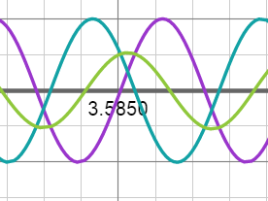
Question: How do sound waves interact when their frequencies are different?

- Compare: Play Sound A. Next, play Sound B. Can you hear any difference in the two sounds? If so, describe how the two sounds are different.

_________________________________________________________________________

_________________________________________________________________________

- Observe: Turn on the Visual for both Sound A and Sound B. Move the Time slider at the bottom of the Gizmo screen back and forth. Describe what you see.

_________________________________________________________________________

_________________________________________________________________________

- Collect data: Move the Time slider all the way to the left. For each of the times listed in the table below, use the Time marker to record the amplitudes of Sound A and Sound B. Then, find the sum of the two amplitudes and record this number in the last column. (Note: Pay attention to negative signs.)

Time (t) | Sound A amplitude | Sound B amplitude | Sound A + B amplitude
0.0006
0.3000
0.4995

- Predict: Study the data you collected. What do you think Sound A and Sound B will sound like when they are played together? ____________________________________________
_________________________________________________________________________

- Observe: Click PLAY to listen to the combined sounds. Describe what you hear: _________

_________________________________________________________________________

_________________________________________________________________________

(Activity B continued on next page)
Activity B (continued from previous page)

- Explain: Why did the volume of the sound change over time? _______________________

_________________________________________________________________________

_________________________________________________________________________

- Observe: When two waves of slightly different frequencies combine, you hear variations in the volume of the sound. The change from soft to loud is called a beat. Click PLAY to listen to the combined sounds again.

How many beats did you hear? ___________

- Identify: The loud part of the beat is the result of constructive interference. The soft part of the beat is the result of destructive interference, which occurs when the crest of one wave and the trough of another overlap. When destructive interference occurs, the resulting wave has a smaller amplitude than the original waves.

Turn on the Visual for Sound A + B. Move the time slider all the way to the left. For each of the following times, determine whether constructive or destructive interference is occurring:

0.0050: ____________________________ 0.5100: ____________________________

0.7550: ____________________________ 2.0175: ____________________________

- Make connections: Click the zoom out control () on the graph three times.

- What do you see? ____________________________________________________

___________________________________________________________________

- How do you think this relates to the number of beats you counted? ______________

___________________________________________________________________

- PLAY the combined sounds. How does the sound relate to the graph’s green wave?

___________________________________________________________________

___________________________________________________________________

Activity C:  Frequencies and beats | Get the Gizmo ready:  - Make sure the Visual for Sound A + B is on.  - Make sure the Frequency of Sound A is 441 Hz, and the Frequency of Sound B is 440 Hz. | 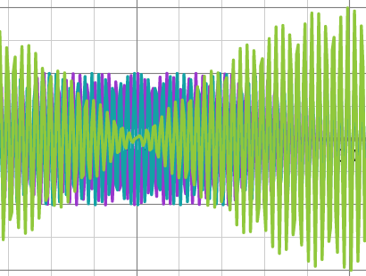
Question: How do the number of beats relate to the frequencies of the two sound waves?

- Predict: Do you think you will hear more beats or fewer beats if you increase the frequency difference between sounds A and B? Explain your answer.

_________________________________________________________________________

_________________________________________________________________________

- Collect data: In the table below, subtract the frequency of Sound B from that of Sound A. Write this number in the third column.

Turn off the Visual for Sound A and Sound B. For each set of frequencies, record the number of beats in 4 seconds. To do this, you can count the beats you hear and then check this value by counting the number of pinched-in areas of the green wave pattern on the graph.

Sound A frequency (Hz) | Sound B frequency (Hz) | Frequency difference (Hz) | N^{o.} of beats in 4 seconds | N^{o.} of beats in 1 second
441 | 440
442 | 440
443 | 440
443 | 439
443 | 438
443 | 437

- Calculate: Divide the number of beats in 4 seconds by 4 in order to find the number of beats per second. Use this figure to fill in the last column of the table.

- Analyze: What relationship do you see between the frequency difference and number of beats in 1 second? _________________________________________________________

- Apply: Suppose a sound wave with a frequency of 444 Hz combined with a sound wave with a frequency of 436 Hz. How many beats would you hear in one second?

_________________________________________________________________________

